**Appendix 1 - Medication Management Pathway**

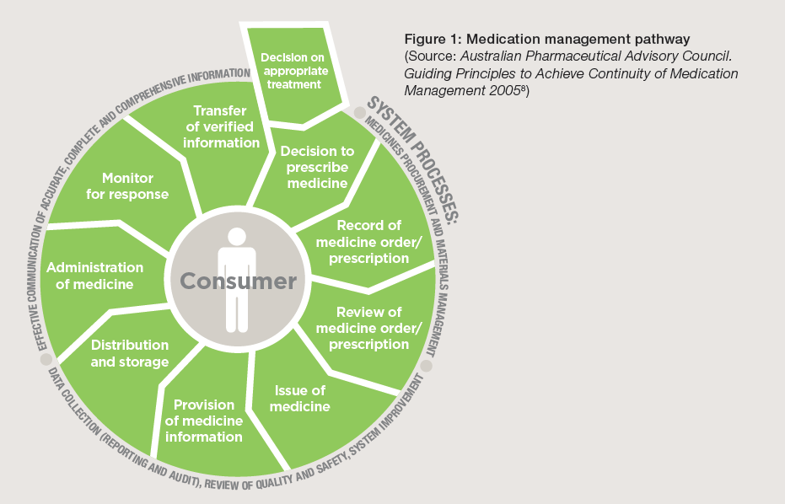

The following diagram is reproduced from Australian Commission on Safety and Quality in Healthcare *Standard 4 Medication Safety: Safety and Quality Improvement Guide Oct 2012*.